Pinchpoint Mapper User Guide
Version 1.1—Updated August 2016

Brad McRae
The Nature Conservancy

Acknowledgements
Pinchpoint Mapper builds on much of the Python code developed with Darren Kavanagh for Linkage Mapper, and uses Circuitscape, developed with Viral Shah. I am grateful for Darren and Viral’s excellent contributions.

Software Requirements and Licensing
Pinchpoint Mapper requires AcrGIS 10.0 with the Spatial Analyst extension. Circuitscape 3.5.8 or later must also be installed on your machine. This code is provided free of charge under a GNU General Public License. More details can be found on the Linkage Mapper website, where our code is hosted: http://www.circuitscape.org/linkagemapper.

Preferred Citation
McRae, B.H. 2012. Pinchpoint Mapper Connectivity Analysis Software. The Nature Conservancy, Seattle WA. Available at: http://www.circuitscape.org/linkagemapper.

Table of Contents
1. Introduction 2
2. Installation 3
3. Using Pinchpoint Mapper 4
3.1 Input data requirements 4
3.2 Running the toolbox 4
3.3 What Pinchpoint Mapper does 5
4. Pinchpoint Mapper tutorial 6
5. Support 7
6. Literature cited 8

1. Introduction
Pinchpoint Mapper is part of the Linkage Mapper Toolkit, which includes Linkage Mapper (McRae and Kavanagh 2011) and other modules designed to support regional wildlife habitat connectivity analyses. Once corridors have been mapped using Linkage Mapper, Pinchpoint Mapper runs Circuitscape (McRae and Shah 2009) within the resulting corridors. This produces current maps that identify and map pinch points (i.e. constrictions, a.k.a. bottlenecks or choke points) in least-cost corridors. It also provides corridor effective resistance values, a measure of connectivity that complements least-cost distances.
More details on the theory behind this approach and on Circuitscape software can be found in McRae et al. (2008) and McRae and Shah (2009) respectively.

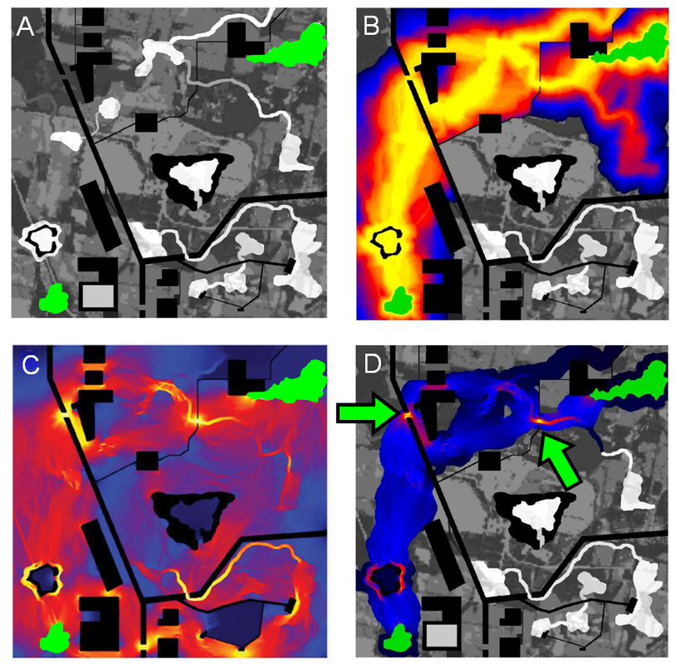
Figure 1. Example of how Pinchpoint Mapper can be used to identify and prioritize important areas for connectivity conservation. (A) Simple landscape, with two patches to be connected (green) separated by a matrix with varying resistance to dispersal (low resistance in white, higher resistance in darker shades, and complete barriers in black). (B) Least-cost corridor between the patches (lowest resistance routes in yellow, highest in blue). (C) Current flow between the same two patches derived using Circuitscape, with highest current densities shown in yellow (from McRae et al. 2008). Circuit analyses complement least-cost path results by identifying important alternative pathways and “pinch points,” where loss of a small area could disproportionately compromise connectivity. (D) Results from Pinchpoint mapper, which constrains current flow to the best corridor. This approach hybridizes least-cost corridor and circuit theory approaches, showing both the most efficient movement pathways and critical pinch points within them. These could be prioritized over areas that contribute little to connectivity, such as the dark blue “corridor to nowhere” at the top right.

2. Installation
1) Install the latest version of Circuitscape
Circuitscape can be downloaded from www.circuitscape.org. If you are running 64-bit windows, make sure to install the 64-bit version.

2) Install the latest version of Linkage Mapper
See the Linkage Mapper User Guide for installation instructions.

3) Verify your installation
You can test the code by running the tutorial below.

3. Using Pinchpoint Mapper

3.1 Input data requirements
Inputs to Pinchpoint Mapper include 1) the same inputs used in Linkage Mapper (a core area polygon layer and a resistance raster) and 2) rasters generated from a completed Linkage Mapper run.

3.2 Running the toolbox

Note: ArcGIS can be finicky about file locks. If you get schema lock or permission errors, you may need to close ArcCatalog and ArcMap and start fresh without any output files displayed.

Note: Although this user guide was written with running from ArcMap in mind, several users have reported that they experience fewer ArcGIS errors when running from ArcCatalog. We therefore suggest you run from ArcCatalog if you are having problems with the tool.
Click the Linkage Mapper toolbox, and open the tool in the Pinchpoint Mapper toolset. The following dialog should appear.

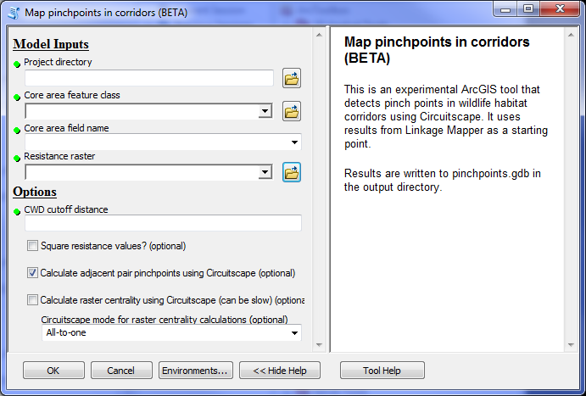
Figure 2. Pinchpoint Mapper dialog.

- Input data
  - Project directory: Use the same project directory used for the Linkage Mapper run.
  - Core area feature class: Use the same core area file you used to create corridors using Linkage Mapper.
  - Core area field name: Use the same core area field name you used to create corridors using Linkage Mapper.
  - Resistance raster: Use the same resistance raster used to create corridors using Linkage Mapper.
- Options
  - CWD cutoff distance: This is how 'wide' corridors should be in cost-weighted distance. See the description of Linkage Mapping Cutoff in Chapter 2 of WHCWG (2010). Corridors will be 'cookie-cut' using this cutoff value.
  - Square resistance values: Some practitioners use higher resistance values for Circuitscape than for least-cost corridor analyses. Squaring values is an easy way to accomplish this (though there is no empirical support either way for doing so).

Note: for processing efficiency in Circuitscape, we recommend that the highest resistance values do not exceed 10,000 times the lowest values.
  - Calculate adjacent pair pinch points using Circuitscape: Run current through individual corridors connecting adjacent core areas as mapped by Linkage Mapper. Current will be limited to areas below the CWD cutoff distance in each corridor. Current values will be mosaicked across all corridors.
  - Calculate raster centrality using Circuitscape: Runs current between all core areas in network. The resistance map will be 'cookie-cut' to the corridor map produced by Linkage Mapper, and will only include areas below the CWD cutoff distance.
  - Circuitscape mode for raster centrality calculations: Pairwise mode will run current between all pairs of core areas. All-to-one mode will tie one core area to ground and inject current into the remaining cores, iterating across all cores. Current will then flow through these areas between all connected core areas. Results for each pair of core areas (pairwise mode) or each core area (all-to-one mode) will be summed in the output current map. Both outputs show areas that have high current flow centrality, indicating their importance for keeping the entire network connected (see McRae et al. 2008, Carroll et al. 2012). Pairwise mode provides a more intuitive centrality measure, but all-to-one mode is faster if you have many core areas. See Circuitscape User Guide for more details on these modes.

3.3 What Pinchpoint Mapper does
Pinchpoint Mapper calls Circuitscape in pairwise and/or all-to one mode. Pairwise mode will be applied for the adjacent pair pinch points option and for raster centrality calculations if pairwise mode is chosen. All-to-one mode will be applied for raster centrality calculations if all-to-one mode is chosen.

Outputs rasters will be written to pinchpoints.gdb in your output directory. If adjacent pair pinch points are run, stick and LCP maps in link_maps.gdb will be updated with effective resistance values (see McRae and Shah 2009) and cwd-to-effective-resistance ratios. Output rasters are named using the following convention:

<Project directory name>_current_<mode>_<cutoff value>_<nodata option>

Mode indicates the run setting, and includes adjacentPairs, allPairs, and allToOne. Cutoff value is the CWD cutoff value used as the corridor width. Nodata option indicates whether core areas have been set to NoData in the output raster (which can help with color ramping your current maps). For raster centrality analyses, maps with and without the NoData option are automatically produced.

4. Pinchpoint Mapper tutorial
After running the Linkage Mapper tutorial, you can analyze pinch points in your output corridors. Open up LM_demo_results.mxd, and run Pinchpoint Mapper using the following settings (substitute the path to your own demo directory). I recommend experimenting with different CWD cutoff distance values to get a feel for how they affect results, and trying the pairwise setting for raster centrality calculations.

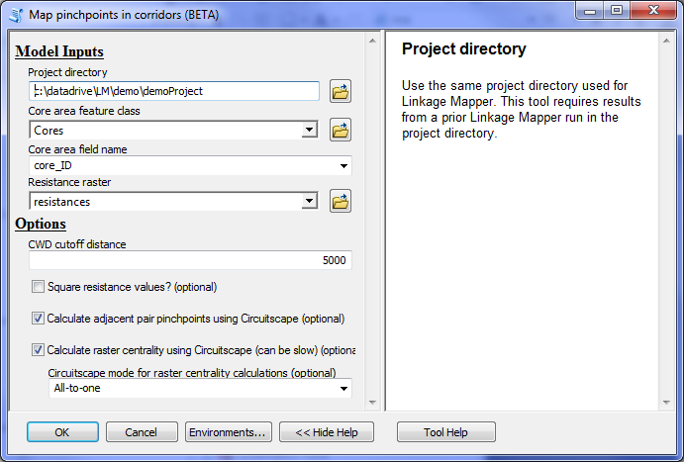
Figure 3. Tutorial settings. Substitute the path to the location of your own demoProject directory.

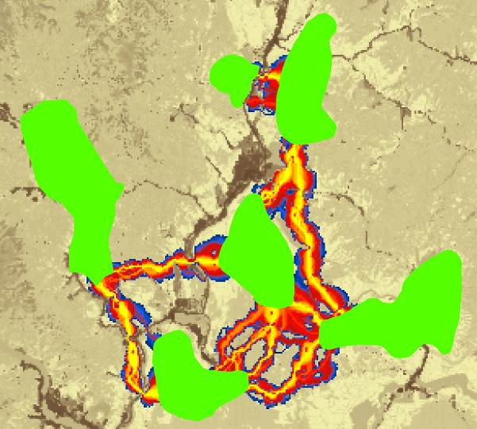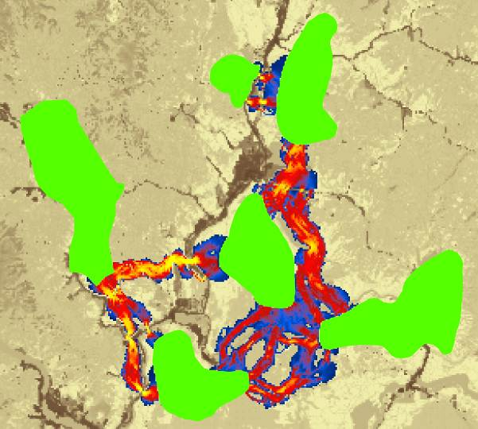
Figure 4. Above left are corridors from Linkage Mapper tutorial. Corridors have been clipped to a 5 km cost-weighted ‘width’ cutoff using the Linkage Mapper Utilities toolset. Right: adjacent pair current maps using 5 km CWD cutoff distance. Areas with high current values (yellow) indicate pinch points within individual corridors. Current densities were symbolized in ArcMap using a quantile classification.

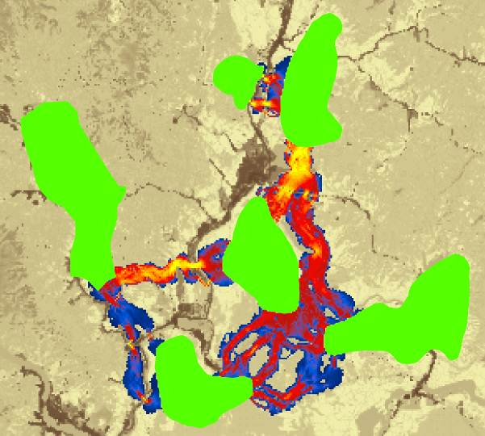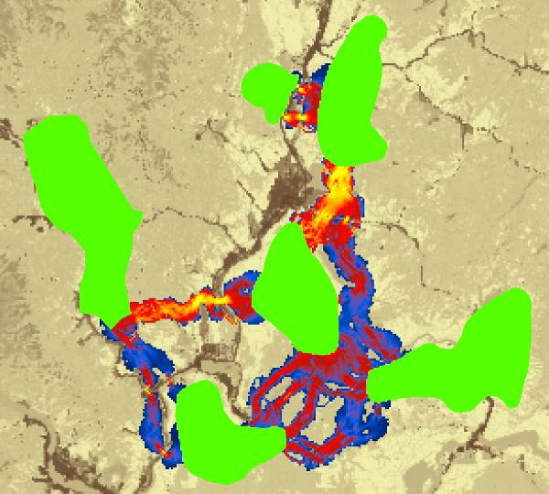
Figure 5. Above left: results from raster centrality analyses using pairwise mode with 5 km CWD cutoff. This shows areas that have high current flow centrality, indicating their importance for keeping the entire network connected (as opposed to keeping a single core area pair connected as in Fig. 4; see McRae et al. 2008, Carroll et al. 2012). Right: raster centrality results using all-to-one mode. Results bear a strong resemblance to pairwise results, but all-to-one can be much faster when there are large numbers of core areas.

5. Support
Please join the Linkage Mapper User Group to get updates, report bugs, and suggest enhancements. You can find a link to the user group on the Linkage Mapper website, where our code is hosted: http://www.circuitscape.org/linkagemapper.

6. Literature cited
Carroll, C., B.H. McRae, and A. Brookes. 2012. Use of linkage mapping and centrality analysis across habitat gradients to conserve connectivity of gray wolf populations in western North America. Conservation Biology 26(1):78-87.
McRae, B.H., B.G. Dickson, T.H. Keitt, and V.B. Shah. 2008. Using circuit theory to model connectivity in ecology, evolution, and conservation. Ecology 10: 2712-2724.
McRae, B.H., and Shah, V.B. 2009. Circuitscape User’s Guide. ONLINE. The University of California, Santa Barbara. Available at: http://www.circuitscape.org.
Washington Wildlife Habitat Connectivity Working Group (WHCWG). 2010. Washington Connected Landscapes Project: Statewide Analysis. Washington Departments of Fish and Wildlife, and Transportation, Olympia, WA. Available at: http://www.waconnected.org.

